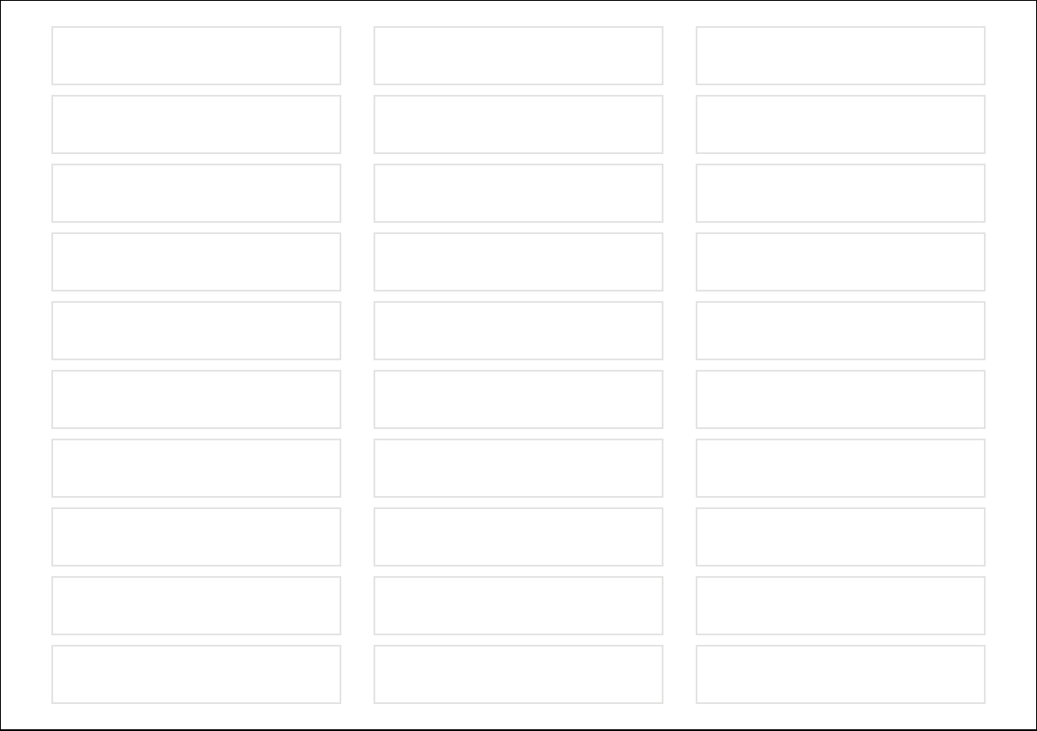

Text

Text

Text

Text

Text

Text

Text

Text

Text

Text

Text

Text

Text

Text

Text

Text

Text

Text

Text

Text

Text

Text

Text

Text

Text

Text

Text

Text

Text

Text